Write a function template named findmax that takes two arguments and return the greater among two. Test it with int, float, and char types.
61).

#include <iostream>
using namespace std;

template <typename T>
T findmax(T a, T b) {
return (a > b) ? a : b;
}

int main() {
int i1, i2;
cout << "Enter two integers: ";
cin >> i1 >> i2;
cout << "Max of " << i1 << " and " << i2 << " is: " << findmax(i1, i2) << endl;

float f1, f2;
cout << "\nEnter two floating-point numbers: ";
cin >> f1 >> f2;
cout << "Max of " << f1 << " and " << f2 << " is: " << findmax(f1, f2) << endl;
char c1, c2;
cout << "\nEnter two characters: ";
cin >> c1 >> c2;
cout << "Max of '" << c1 << "' and '" << c2 << "' is: '"<< findmax(c1,c2) << "'" << endl;
return 0;
}
- Output:
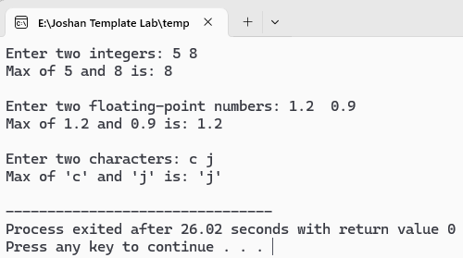

Create a template function display () that takes single value. Overload it to accept two values of different types and print them together.
62).

#include <iostream>
using namespace std;

// Template function for single value
template <class T>
void display(T value) {
cout << "Value: " << value << endl;
}

// Overloaded template function
template <typename T1, typename T2>
void display(T1 value1, T2 value2) {
cout << "Values: " << value1 << " , " << value2 << endl;
}

int main() {
cout << "Enter an integer: ";
int i;
cin >> i;
display(i);
cout << "\nEnter a floating-point number: ";
float f;
cin >> f;
display(f);
cout << "\nEnter a character: ";
char c;
cin >> c;
display(c);
cout << "\n--- Now testing with two values ---\n";
cout << "Enter an integer and a float: ";
int i2;
float f2;
cin >> i2 >> f2;
display(i2, f2);
cout << "\nEnter a character and an integer: ";
char c2;
int i3;
cin >> c2 >> i3;
display(c2, i3);
return 0;
}

- Output:
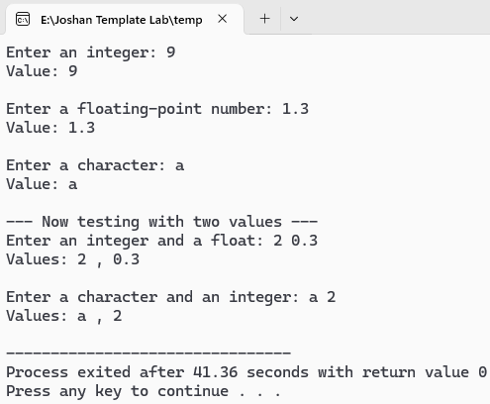

WAP that takes two integers and perform division. If denominator is zero, throw an exception and catch it to display error message.
63).

#include <iostream>
using namespace std;

int main() {
int dividend, divisor;
cout << "Enter dividend: ";
cin >> dividend;
cout << "Enter divisor: ";
cin >> divisor;

try {
if (divisor == 0) {
throw string ("Error: Division by zero is not allowed!");
}
double result =double(dividend) / divisor;
cout << "Result: " << result << endl;
}
catch (string e) {
cout << e << endl;
}
return 0;
}
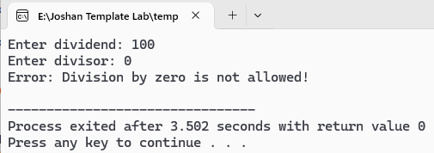
- Output:
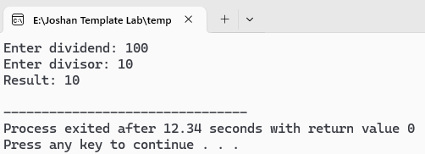

WAP that takes two integers and perform division. If denominator is zero, throw an exception and catch it to display error message.
64).

#include <iostream>
using namespace std;

int main() {
float num;
cout << "Enter a number: ";
cin >> num;
try {
if (num < 0) {
throw 'N'; // throw char
}
else if (num == 0) {
throw 0; // throw int
}
else {
throw 0.2; // throw something else
}
}
catch (char c) {
cout << "!!!Negative number entered!!!" << endl;
}
catch (int i) {
cout << "!!! Zero entered!!!" << endl;
}
catch (...) {
cout << "!!!Caught ellipsis !!!" << endl;
}
return 0;
}
- Output:
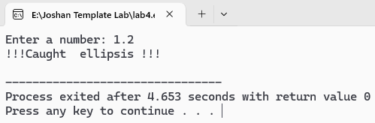
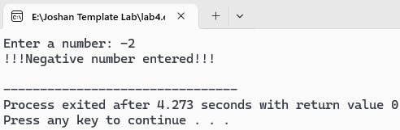

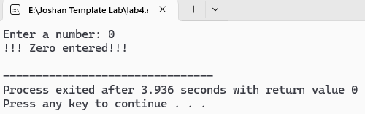

Create a class template named whose class name is calculator to perform basis operations on generic types. Also handle divide by zero exception in this class.
65).

#include <iostream>
using namespace std;

template <typename T>
class Calculator {
private:
T a, b;
public:
Calculator(T x, T y) : a(x), b(y) {}
T add() {
return a + b;
}
T subtract() {
return a - b;
}
T multiply() {
return a * b;
}
T divide() {
try {
if (b == 0) {
throw string("Error: Division by zero is not allowed!");
}
return a / b;
}
catch (string &e) {
cout << e << endl;
return 0;
}
}
};

int main() {
int x, y;
cout << "Enter two integers: ";
cin >> x >> y;
Calculator<int> intCalc(x, y);

cout << "Addition: " << intCalc.add() << endl;
cout << "Subtraction: " << intCalc.subtract() << endl;
cout << "Multiplication: " << intCalc.multiply() << endl;

cout << "Division: " << intCalc.divide() << endl;

cout << "\nEnter two floats: ";
float p, q;
cin >> p >> q;
Calculator<float> floatCalc(p, q);
cout << "Addition: " << floatCalc.add() << endl;
cout << "Subtraction: " << floatCalc.subtract() << endl;
cout << "Multiplication: " << floatCalc.multiply() << endl;
cout << "Division: " << floatCalc.divide() << endl;

return 0;
}
- Output:
